**EE5320 Analog IC Design**

**Fully Differential Op-Amp Design**

Sarvjit Ajit Patil EE21S079

-----------------------------------------------------------------------------------------------------------------------------------------------------------

OpAmp Schematic:

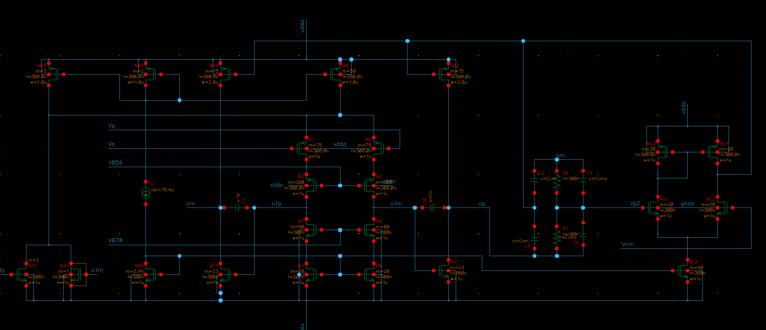

Test Bench:

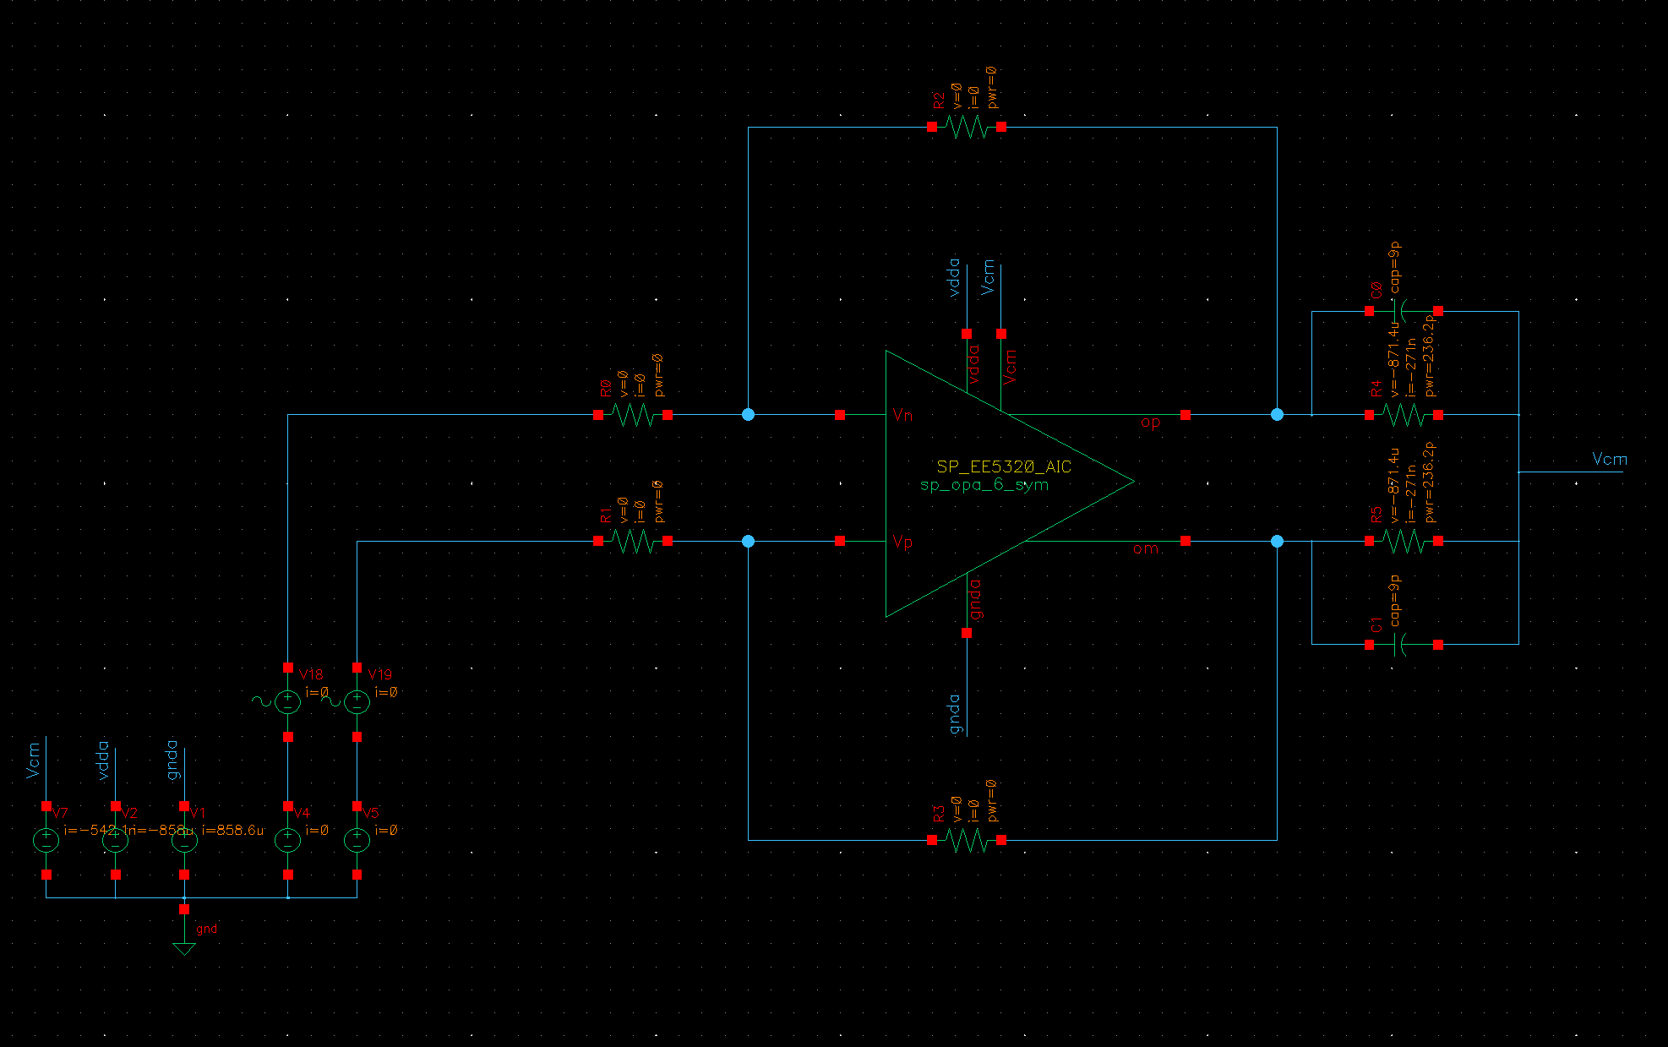

|  |  |
| --- | --- |
| Table 1: Specifications | |
| Closed loop dc gain | 15 |
| Closed loop bandwidth |  |
| Load capacitor CL |  |
| Load resistor RL |  |
| Input resistance Ri |  |
| Rf |  |
| Gm1 |  |
| Gm2 |  |
| Cc |  |
| Ccm | 4 |
| Ccmx | 4 |

Plots:

1. Loop Gain:

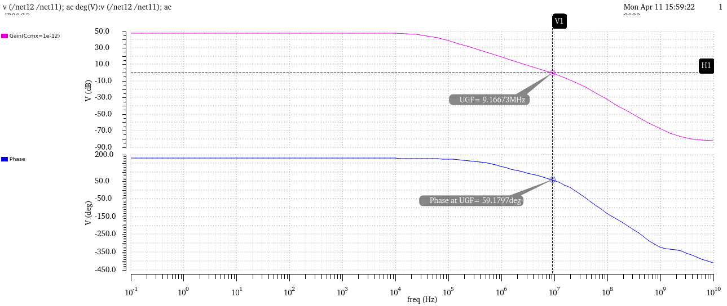

1. Closed Loop Transfer Function:

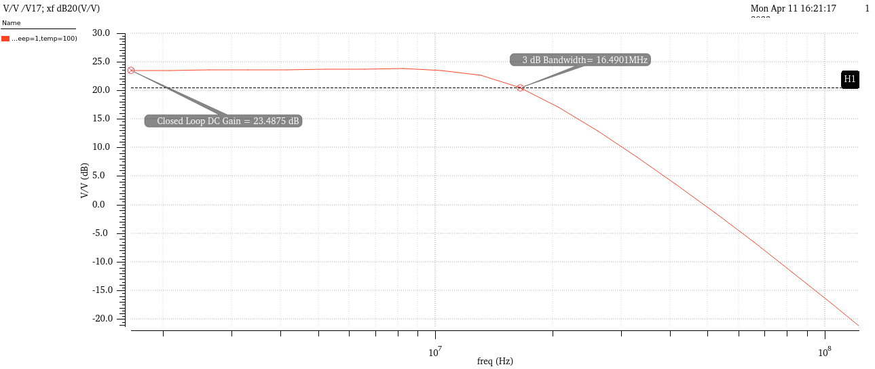



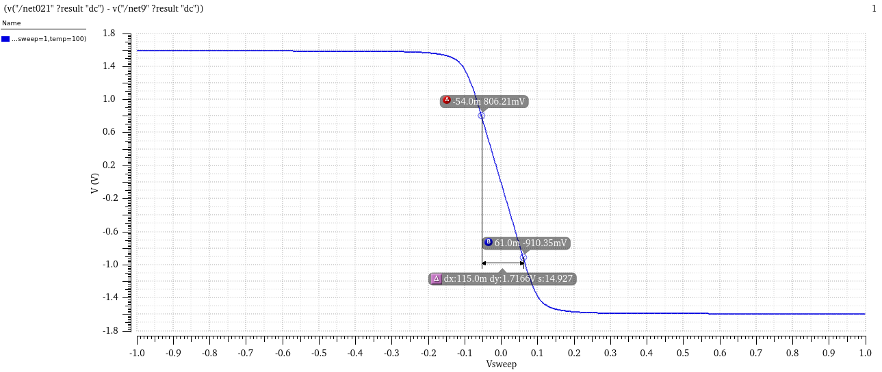

1. Small Signal Step Response:

Rise Time = 21.25 nS

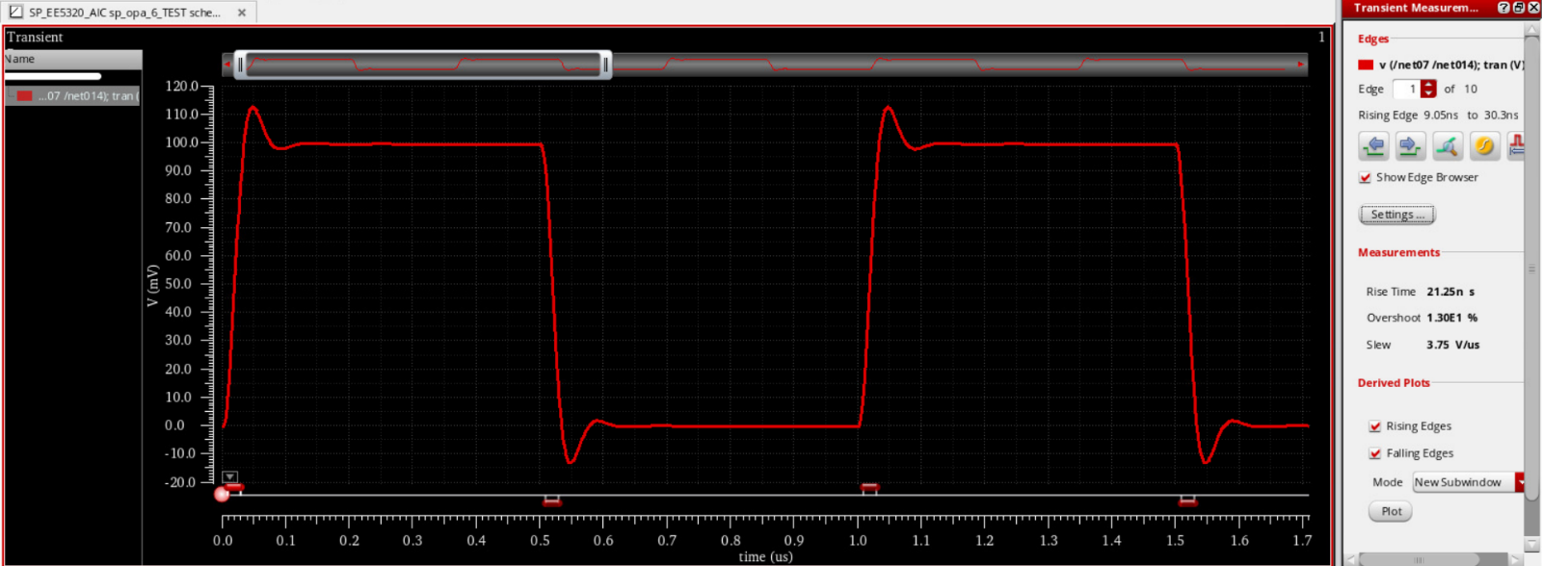

Fall Time = 21.22 ns

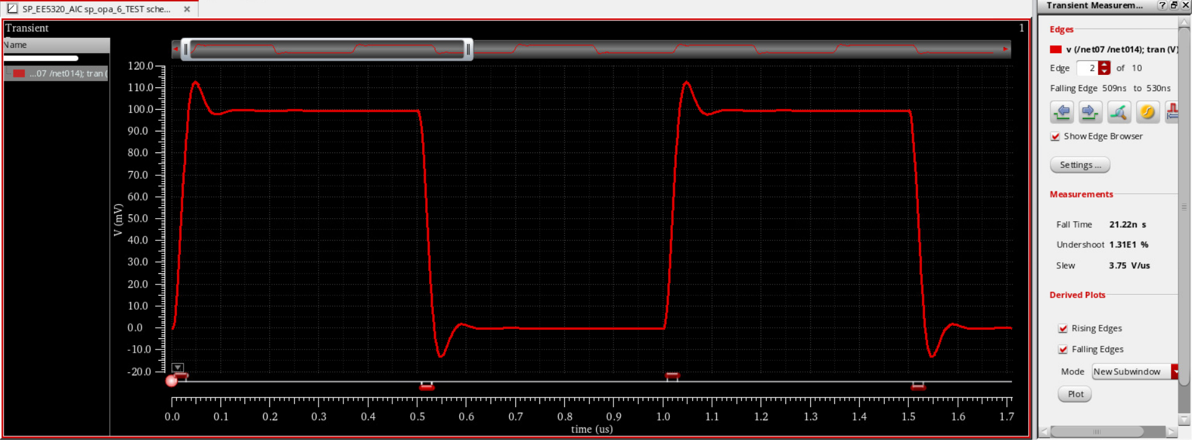

1. Large Signal Step Response:

Rise Time = 4.751 ns

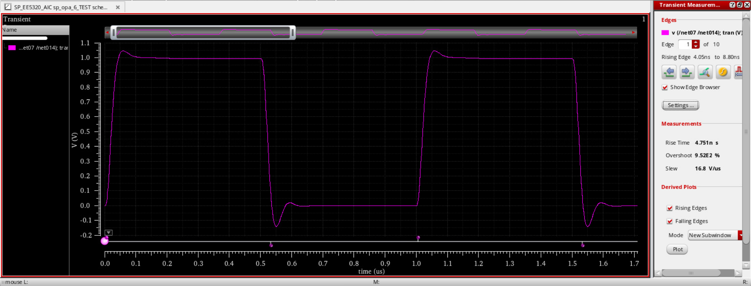

Fall Time = 3.079 ns

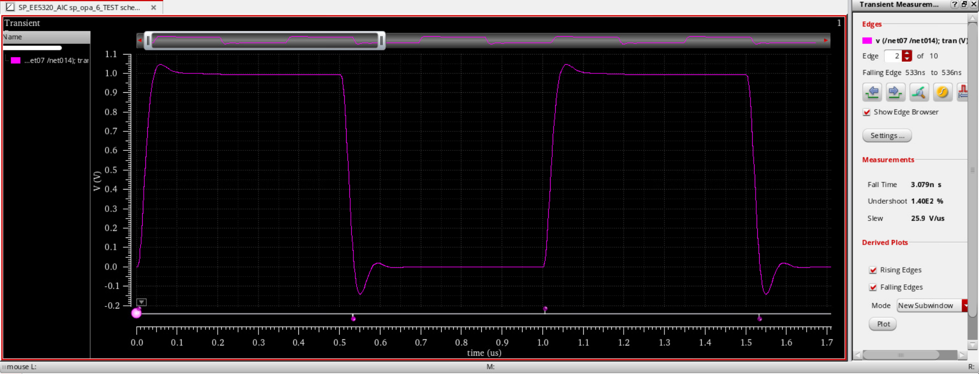

1. Output noise PSD:

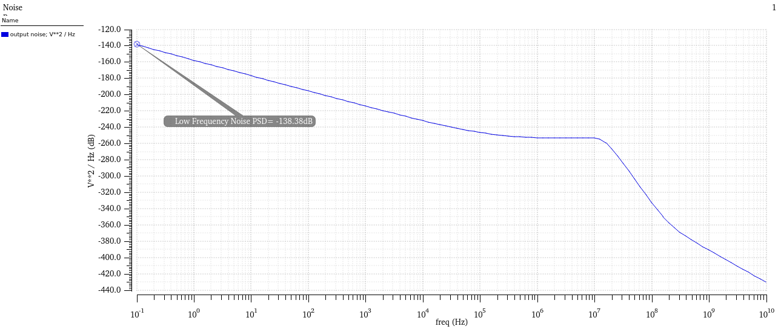

1. Input Referred noise PSD:

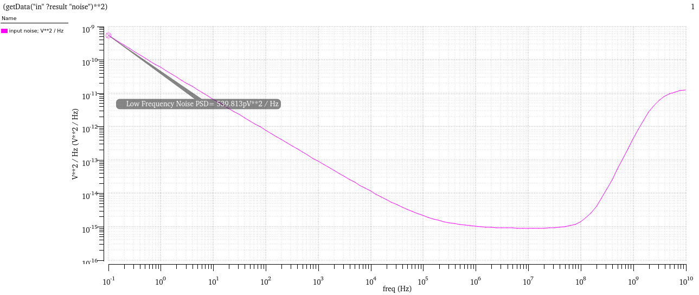

1. Input Referred Noise PSD of OpAmp:

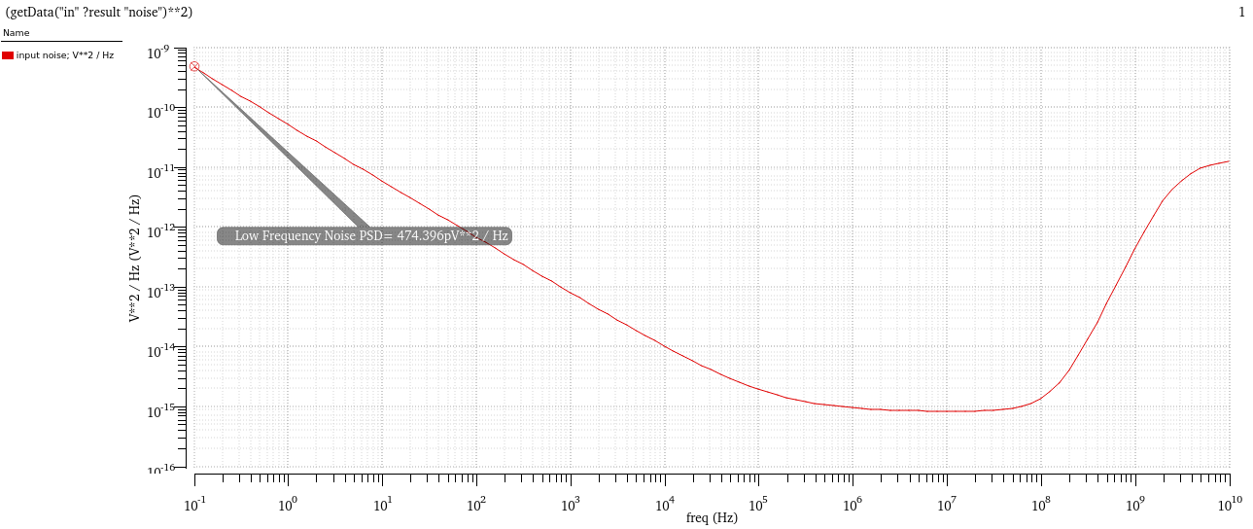

1. CMFB2 Loop gain:

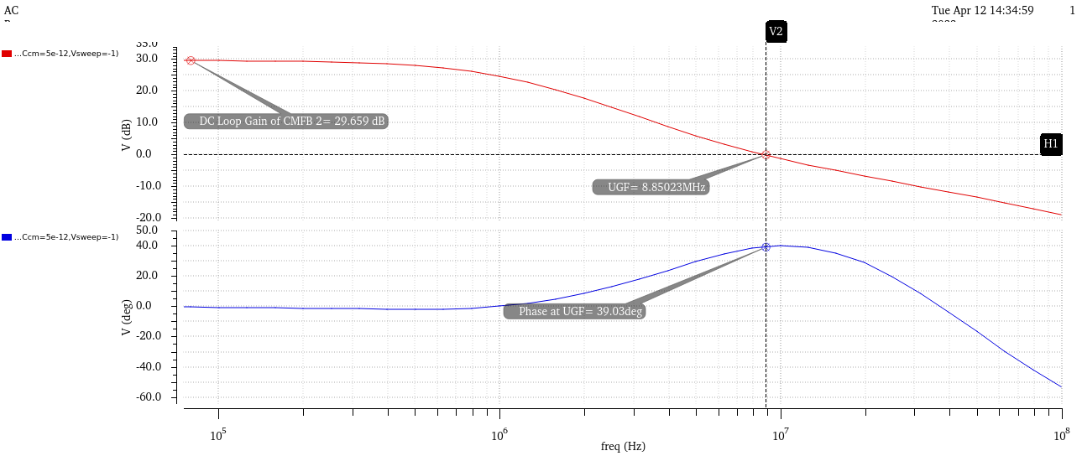

1. HD3:

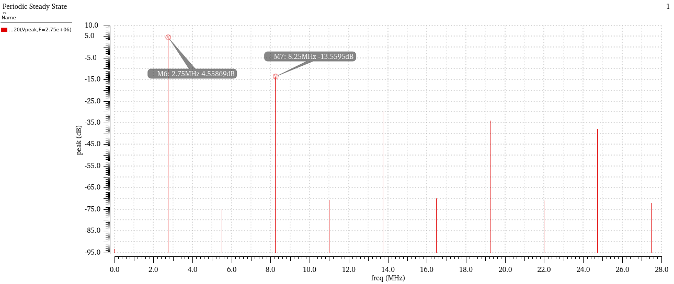

**HD3 = -18.118 dB**

|  |  |  |  |  |  |
| --- | --- | --- | --- | --- | --- |
| **Table 2: Transistor sizes and operating points** | | | | | |
| **Transistor** | **nMOS/pMOS** | **W/L** | **Bias current** | **gm** | **gds** |
| **M00** | pMOS | 2u/0.3u | 15.4uA | 96.19 uS | 21.29 uS |
| **M0** | pMOS | 30u/0.3u | 204.6uA | 1.211 mS | 164.5 uS |
| **M01** | nMOS | 3u/0.3u | 15.4uA | 203.2 uS | 3.311 uS |
| **M1,2** | pMOS | 75u/0.3u | 99.28uA | 1.265 mS | 73.79 uS |
| **M3,4** | nMOS | 20u/0.3u | 99.28uA | 1.292 mS | 99.88 uS |
| **M5,6** | pMOS | 200u/0.3u | 99.28uA | 1.796 mS | 17.5 us |
| **M7,8** | nMOS | 80u/0.3u | 99.28uA | 1.796 mS | 30.52 uS |
| **M11** | nMOS | 23u/0.3u | 206.5uA | 2.36 mS | 32.8 us |
| **M12** | pMOS | 30u/0.3u | 206.8uA | 1.39 mS | 2129 uS |
| **M0x** | pMOS | 2u/0.3u | 13.64uA | 80.74 uS | 10.97 uS |
| **M3x,M4x** | nMOS | 1u/0.3u | 9.874uA | 109.1 uS | 1.33 uS |
| **Mc0** | nMOS | 40u/0.3u | 211.1uA | 2.797 mS | 96.889 uS |
| **Mc1,c2** | nMOS | 20u/0.3u | 105.3 uA | 1.46 mS | 20.02 uS |
| **Mc3,c4** | pMOS | 20u/0.3u | 105.3 uA | 813.1 uS | 14.36 uS |

|  |  |
| --- | --- |
| **Table 3: Simulation results** |  |
| Supply voltage | 1.8 V |
| Power consumption | 1.358 mW |
| Closed loop dc gain | 14.94 |
| Closed loop 3dB frequency | 16.49 MHz |
| Opamp dc gain | 72.2 dB |
| DC loop gain | 48.05 dB |
| Unity loop gain frequency | 9.166 MHz |
| Phase margin | 59.1797 deg |
| Positive slew rate | 28.6 V/us |
| Negative slew rate | 29.04 V/us |
| Low frequency input noise PSD | -185.355 dBc/Hz |
| CMFB2 DC loop gain | 29.66 dB |
| CMFB2 Unity loop gain frequency | 8.85023 MHz |
| CMFB2 phase margin | 39.03 deg |
| HD3 | -18.118 dB |
| **Percentage noise contributions from:** | |
| Ri | 0.82% |
| Rf | 0.03% |
| RL | 0% |
| M1,2 | 3.29% |
| M3,4 | 95.9% |
| M5,6,7,8 | 0.08% |
| M11,12 | 0% |
| M0,M00 | 0% |